### HOTEL RESERVATION REQUEST



**Seoul Hongdae**

♦ Please complete this form and return directly by e-mail or FAX to us.

Reservation. Tel: +82 768 3000, Fax: +82 768 3001, E-mail: reservation@hiex-seoulhongdae.com

|  |  |
| --- | --- |
| Last Name (Mr./Ms.): | First Name: |
| Event: 2020 International Congress of Diabetes and Metabolism (ICDM 2020), 17-19 September 2020 | |
| Venue: Grand Hilton Convention Center (Swiss Grand Hotel) | |
| Phone No.: | Fax No.: |
| Email: | Sharing Room with: |
| Check-in Date: | Arrival Flight No./ Time: |
| Check-out Date: | Departure Flight No./ Time: |

♦ Special Offer Rate:

|  |  |  |  |  |
| --- | --- | --- | --- | --- |
| Hotel | Room Type | Size | Room Rate | Breakfast |
| **Holiday Inn**  **Express**  **Seoul**  **Hongdae** | **Superior**  **Double** | **22sqm** | **□ KRW143,000**  (USD 130~) | **□ Free**  **(2 PAX)** |
| **Superior**  **Twin** | **22sqm** |

* 10% government tax is included on above rate.

* Cancellation or No Show on the arrival date will be charged as a full night’s rate per room.

* Parking in not available.

* Airport Limousine 6002, A’REX Airport Subway ICN(50min), GMP(20min)

* Bus(Blue)753 to Venue(Conrad Hotel) (20min)

♦ A credit card number is required to guarantee your reservation.

|  |  |
| --- | --- |
| Card: □ Amex □ Diners □ Master □ Visa □ JCB | 4 digit # for AMEX: _ _ _ _ |
| Card Number: | Expiry Date: |

* Check-in time - 3:00 pm, Check-out time - 12:00 noon.

♦ Please indicate special requests and comments;

Date: Signature:

**▶ Holiday Inn Express Seoul Hongdae**

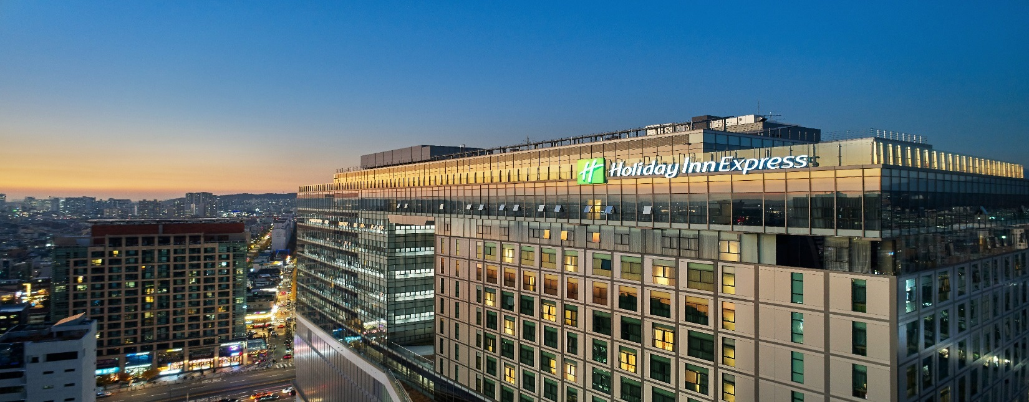

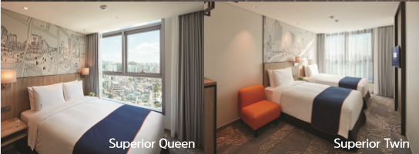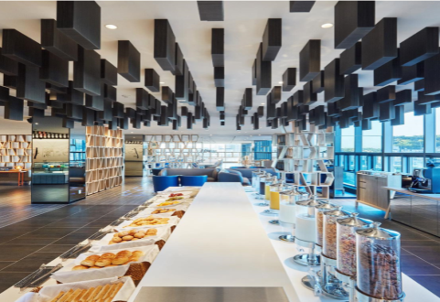

**▶ Address**

Yanghwa Street 188, Mapo Gu, Seoul, Korea, (Exit 5, Hongik Univ. station)

**▶ Website**

* [www.hiex-seoulhongdae.com](http://www.hiex-seoulhongdae.com)

**▶ Transportation**

* Airport: (1) Limousine 6002, (2) A’REX Airport Subway ICN(50min), GMP(20min)
* Venue ↔ Hongik Univ station(Exit3): **Shuttle bus from Grand Hilton Hotel**

|  |  |  |  |
| --- | --- | --- | --- |
| **From Venue** | | **From Hongik Univ. Station(Exit 3)** | |
| 09:00 | 15:30 | 09:40 | 15:40 |
| 10:30 | 16:30 | 10:40 | 16:40 |
| 11:30 | 17:30 | 11:40 | 17:40 |
| 12:30 | 18:30 | 12:40 | 18:40 |
| 13:30 | 19:30 | 13:40 | 19:40 |
| 14:#0 | 20:30 | 14:40 | 20:40 |

* Note : The time table can be modified depending on hotel’s condition or seasons.